**Problema 1010**

import java.io.IOException;

import java.util.Scanner;

public class Main {

public static void main(String[] args) throws IOException {

Scanner sc = new Scanner(System.in);

int codigo1 = sc.nextInt();

int quantidade1 = sc.nextInt();

double valor1 = sc.nextDouble();

int codigo2 = sc.nextInt();

int quantidade2 = sc.nextInt();

double valor2 = sc.nextDouble();

double valorTotal = quantidade1 * valor1 + quantidade2 * valor2;

System.out.println("VALOR A PAGAR: R$ " + String.format("%.2f", valorTotal));

}

}

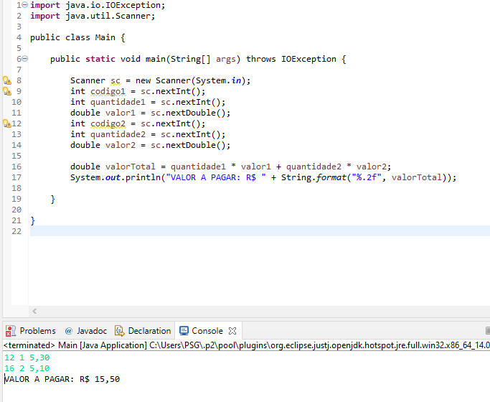

**Problema 1011**

import java.io.IOException;

import java.util.Scanner;

public class Main {

public static void main(String[] args) throws IOException {

Scanner sc = new Scanner(System.in);

double raio = sc.nextDouble();

double volume = (4 / 3.00) * 3.14159 * Math.pow(raio, 3);

System.out.println("VOLUME = " + String.format("%.3f", volume));

}

}

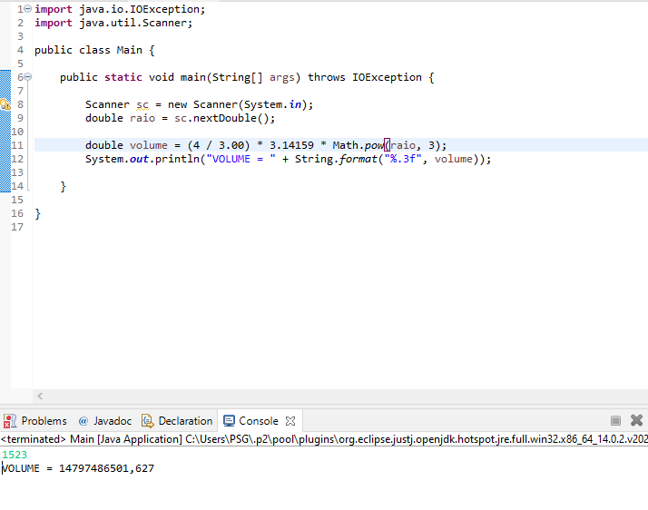

**Problema 1012**

import java.io.IOException;

import java.util.Scanner;

public class Main {

public static void main(String[] args) throws IOException {

Scanner sc = new Scanner(System.in);

double a = sc.nextDouble();

double b = sc.nextDouble();

double c = sc.nextDouble();

double areaTriangulo = a * c / 2;

double areaCirculo = 3.14159 * Math.pow(c, 2);

double areaTrapezio = (a + b) * c / 2;

double areaQuadrado = Math.pow(b, 2);

double areaRetangulo = a * b;

System.out.println("TRIANGULO: " + String.format("%.3f", areaTriangulo));

System.out.println("CIRCULO: " + String.format("%.3f", areaCirculo));

System.out.println("TRAPEZIO: " + String.format("%.3f", areaTrapezio));

System.out.println("QUADRADO: " + String.format("%.3f", areaQuadrado));

System.out.println("RETANGULO: " + String.format("%.3f", areaRetangulo));

}

}

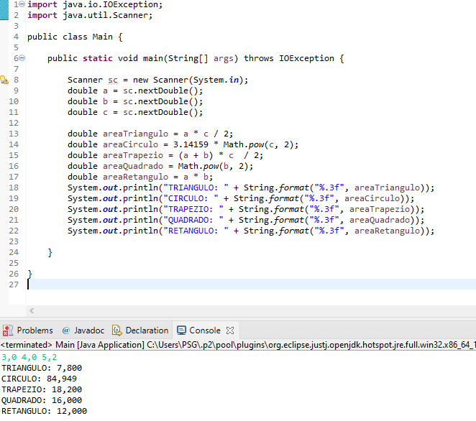

**Problema 1013**

import java.io.IOException;

import java.util.Scanner;

public class Main {

public static void main(String[] args) throws IOException {

Scanner sc = new Scanner(System.in);

int a = sc.nextInt();

int b = sc.nextInt();

int c = sc.nextInt();

int maiorAB = (a + b + Math.abs(a - b))/2;

int maiorABC = (maiorAB + c + Math.abs(maiorAB - c))/2;

System.out.println(maiorABC + " eh o maior");

}

}

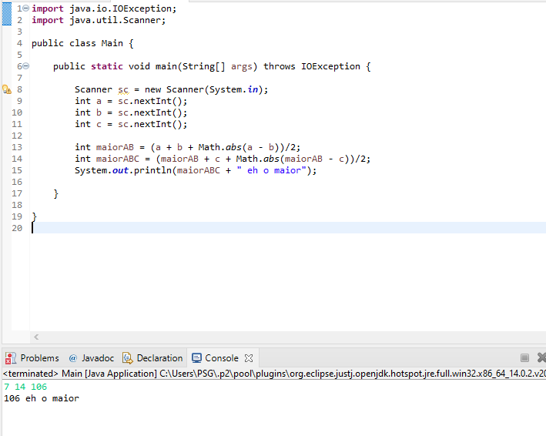

**Problema 1014**

import java.io.IOException;

import java.util.Scanner;

public class Main {

public static void main(String[] args) throws IOException {

Scanner sc = new Scanner(System.in);

int distancia = sc.nextInt();

double gasto = sc.nextDouble();

double consumoMedio = distancia / gasto;

System.out.println(String.format("%.3f", consumoMedio) + " km/l");

}

}

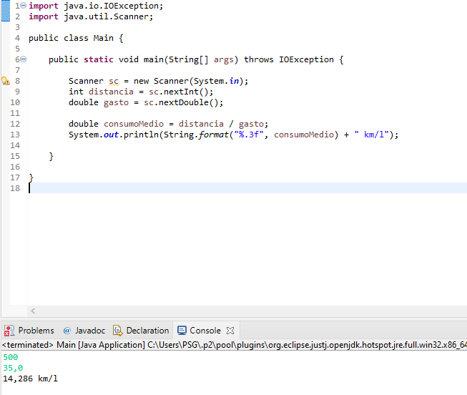

**Problema 1015**

import java.io.IOException;

import java.util.Scanner;

public class Main {

public static void main(String[] args) throws IOException {

Scanner sc = new Scanner(System.in);

double x1 = sc.nextDouble();

double y1 = sc.nextDouble();

double x2 = sc.nextDouble();

double y2 = sc.nextDouble();

double distancia = Math.sqrt(Math.pow((x2 - x1), 2) + Math.pow((y2 - y1), 2));

System.out.println(String.format("%.4f", distancia));

}

}

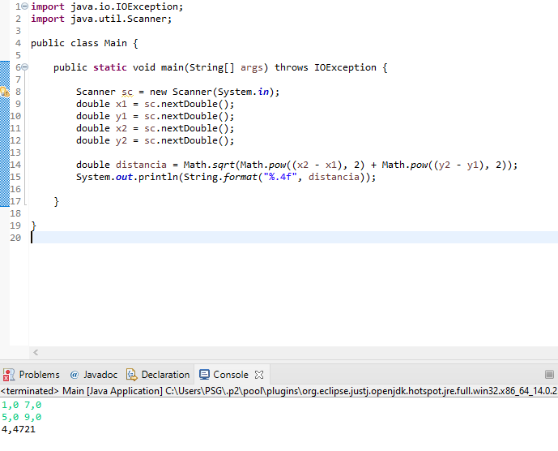

**Problema 1016**

import java.io.IOException;

import java.util.Scanner;

public class Main {

public static void main(String[] args) throws IOException {

Scanner sc = new Scanner(System.in);

int distancia = sc.nextInt();

int minutos = 2 * distancia;

System.out.println(minutos + " minutos");

}

}

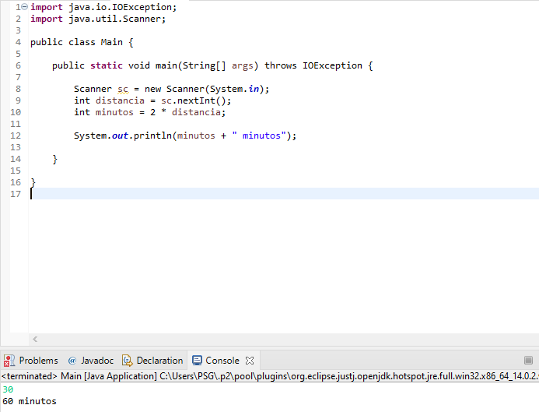

**Problema 1017**

import java.io.IOException;

import java.util.Scanner;

public class Main {

public static void main(String[] args) throws IOException {

Scanner sc = new Scanner(System.in);

int primeiro = sc.nextInt();

int segundo = sc.nextInt();

double multiplicacao = primeiro * segundo;

double resultado = multiplicacao / 12;

System.out.println(String.format("%.3f", resultado));

}

}

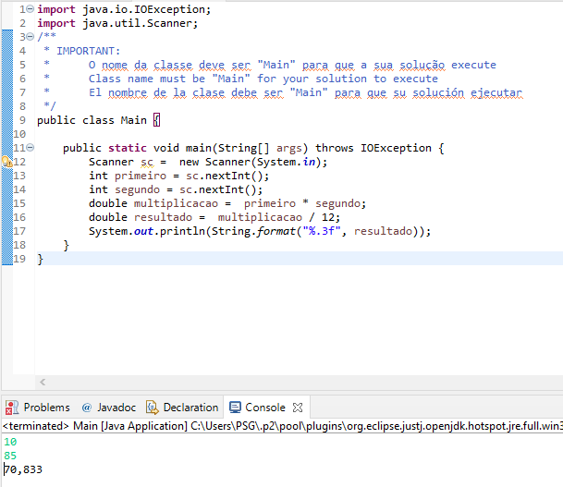

**Problema 1018**

import java.io.IOException;

import java.util.Scanner;

public class Main {

public static void main(String[] args) throws IOException {

Scanner sc = new Scanner(System.in);

int n = sc.nextInt();

System.out.println(n);

int cedulas = n / 100;

int resto = n % 100;

System.out.println(cedulas + " nota(s) de R$ 100,00");

cedulas = resto / 50;

resto = resto % 50;

System.out.println(cedulas + " nota(s) de R$ 50,00");

cedulas = resto / 20;

resto = resto % 20;

System.out.println(cedulas + " nota(s) de R$ 20,00");

cedulas = resto / 10;

resto = resto % 10;

System.out.println(cedulas + " nota(s) de R$ 10,00");

cedulas = resto / 5;

resto = resto % 5;

System.out.println(cedulas + " nota(s) de R$ 5,00");

cedulas = resto / 2;

resto = resto % 2;

System.out.println(cedulas + " nota(s) de R$ 2,00");

cedulas = resto / 1;

System.out.println(cedulas + " nota(s) de R$ 1,00");

}

}

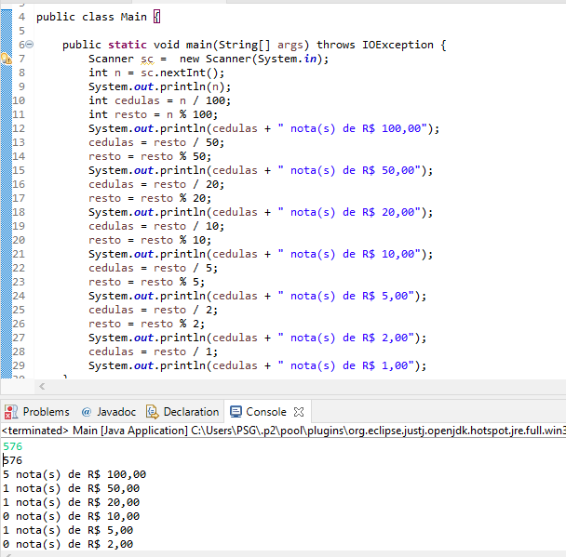

**Problema 1019**

import java.io.IOException;

import java.util.Scanner;

public class Main {

public static void main(String[] args) throws IOException {

Scanner sc = new Scanner(System.in);

int n = sc.nextInt();

int horas = n / 3600;

int segundos = n % 3600;

int minutos = segundos / 60;

segundos = segundos % 60;

System.out.println(horas + ":"+ minutos + ":" + segundos);

}

}

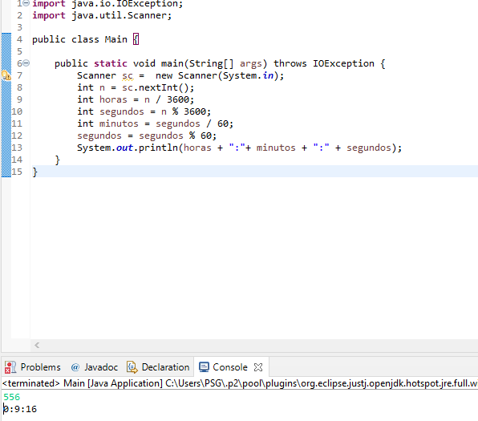

**Problema 1020**

import java.io.IOException;

import java.util.Scanner;

public class Main {

public static void main(String[] args) throws IOException {

Scanner sc = new Scanner(System.in);

int dias = sc.nextInt();

int anos = dias / 365;

int resto = dias % 365;

int meses = resto / 30;

resto = resto % 30;

System.out.println(anos + " ano(s)");

System.out.println(meses + " mes(es)");

System.out.println(resto + " dia(s)");

}

}

